Week 2—login request flow

What I worked on this week:
I reviewed the source code of the Phoenix project and traced the files involved in the login process to understand how the login request travels from the frontend to the backend and database.

completed login request flow:
When the user enters their username and password on the login page, the request starts from the frontend.
The LgoinForm collects the details, and then authApi.js sends this request to the backend.
The request reaches the API gateway and goes through.
- user.routes.ts → user.controller.js → user.grpc.ts
The user.grpc.yc sends their result to the user services.
Inside the user service, the request for thorough
- user.handlers.ts → user.service.ts
the user.service.ts checks the login details and then compares them with the database to find the user and verify the login.

trust boundary:
The frontend is unstirred because the request comes from the user’s browser. The request then moved into the backend, but user input is still treated as untrusted until it is checked by the user.service.ts

flow diagram:
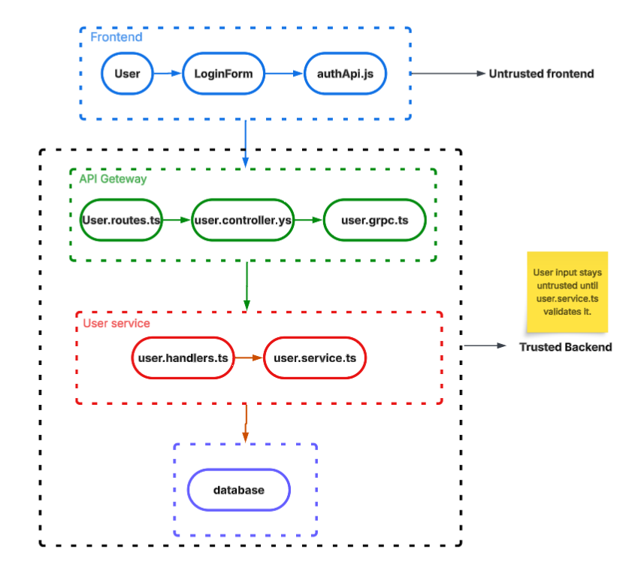

next plan:
The next plan is to start my week 3 task by testing the logout session and checking if the old access and refresh tokens can still be used after logging out.

